DEBASHISH NANDI
ADDRESS
Nagarkot Flats,
Block – A ½ , Kadma,
Jamshedpur - 831005,
Jharkhand
E-mail:- nandidebashish5@gmail.com
Mob No. : 7809552224
Objective:
With the professional knowledge and technical skills I aspire to render quality services keeping my goals in tendon with those of organization. In time, I aim to reach position of responsibility where every day is a challenge to learn, perform and deliver.
Work Experience:
- Have 1year 7months working experience in Wipro Technologies.
- In which have 6months experience in Manual Testing .
- Have 5months experience in Big Machine CRM, where responsibility was as support executive.
- Gone through multiple trainings on Web Designing, Drupal8 and AEM.

Academic Credentials:
Degree | Year of Passing | Board/ university | Percentage
B.Tech(CSE)  12TH  10TH | 2015  2010  2008 | ITER  ISC  ICSE | 78.5%  69%  74%
Strength:
- Ability to work individually as well as a team member with good leadership quality.
- Hardworking & Responsible.
- Punctual.

Subject of Interest:
- OOPS

- Database Management System

- Software Engineering

Technical Activities:
- 6 months experience in Manual Testing , where major role was creating test scripts according to the test cases and execution of the same .

- 5 months experience in Support on BigMachine CRM where major responsibility were :
- Creating Incident and keeping track of those using Service Now tool.
- Providing access to the customer’s users as per the requirement in DealDesk.
- Mainting of Migration sheet and attending the scrum calls. .

Personal Information:
Name : Debashish Nandi

Father’s Name : Madhu Sudan Nandi

Date of Birth : 10/04/1992

Gender : Male

Nationality : Indian

Blood Group : O+ ve

Languages : English, Hindi , Bengoli

Interest : Teaching

Declaration: I hereby declare that the information furnished above is true to the best of my knowledge and belief.
Place : Bhubaneswar 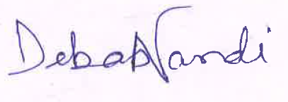
Date : 28-03-2017 (DEBASHISH NANDI)

